Walk through all three aspects mentioned above, see screenshots for what I missed in the video . I Discuss why I chose the specific solution. What are its advantages and disadvantages for the compute and storage parts.

**I have chosen to write code locally in Visual Studio and run it remotely on an EC2 instance via SSH**, because this is a very developer friendly and powerful setup.

I could:

1. **Write and edit code locally** in Visual Studio, where I have full control, extensions, and versioning.
2. **Execute and test** my code on a remote EC2 instance that better matches the final deployment environment.
3. Avoid using the **AWS EC2 web console**, which is limited for development and not ideal for debugging, editing files, or managing dependencies.

This workflow combines **local development convenience** with **cloud compute power**.

## **Advantages**

### **EC2**

EC2 allows you to choose exactly how much CPU/RAM you need for your workload.

You can mimic a production environment (e.g., Linux server, Python version) that is more realistic than your local machine.

You can run training scripts, services, or jobs that take hours or days.

### **Storage ( Instance Store)**

Data stored in your EC2 instance’s EBS volume persists across reboots.

Because your CSV and output files live directly on the EC2 machine, your scripts have low-latency access to large datasets.

You can organize, delete, or move files freely on the instance.

## **Disadvantages**

### **Compute**

Leaving EC2 instances running 24/7 can be expensive. You have to manage shutdowns to avoid unnecessary charges.

You must install Python, libraries, and tools yourself on the EC2 instance.

Debugging is harder without a visual debugger unless you use remote tools (e.g., SSH port forwarding or VS Code Remote Extensions).

### **Storage**

EC2 instances come with limited EBS or instance store capacity unless you explicitly increase it.

If you're using instance store instead of EBS, you can lose all your data on instance termination.

You must use scp or rsync to move files between your machine and the EC2 server, which adds friction.

Conclusion

**Using SSH with EC2 gives you the best of both worlds**: the comfort and power of local development tools, combined with the scalable compute and realistic environment of a cloud server.

It's especially ideal for:

Running large data processing or model training jobs.

Testing code in a Linux environment.

Avoiding the limitations of the AWS Console.

Config to SSH into my EC2 instance named Data612ProjectTag

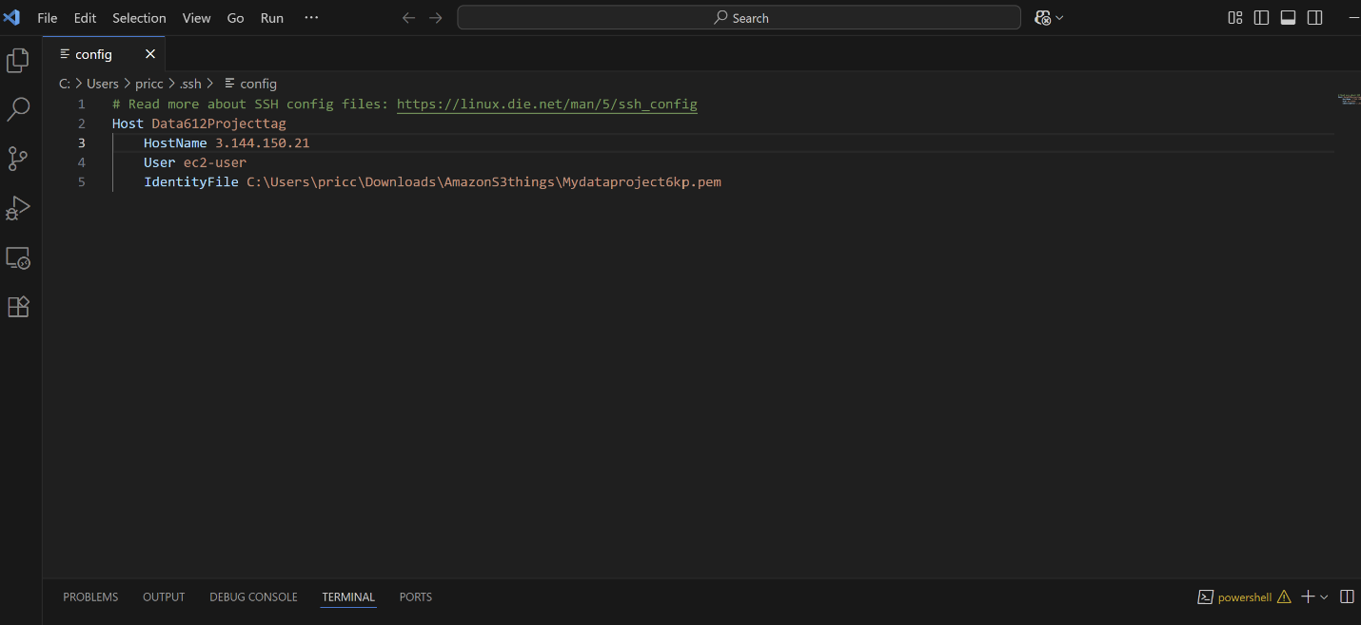

Public Id Address must be updated in config each time a remote connection is initiated

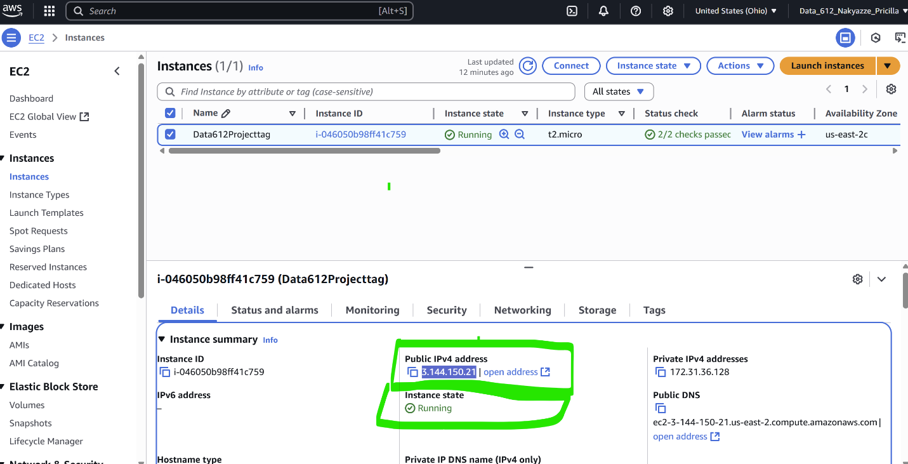

VPC Security. A security group comes with each instance by default. Inbound traffic for SSH can be allowed from only my IP address to manage security and once this security group is saved it can be applied to other instances.

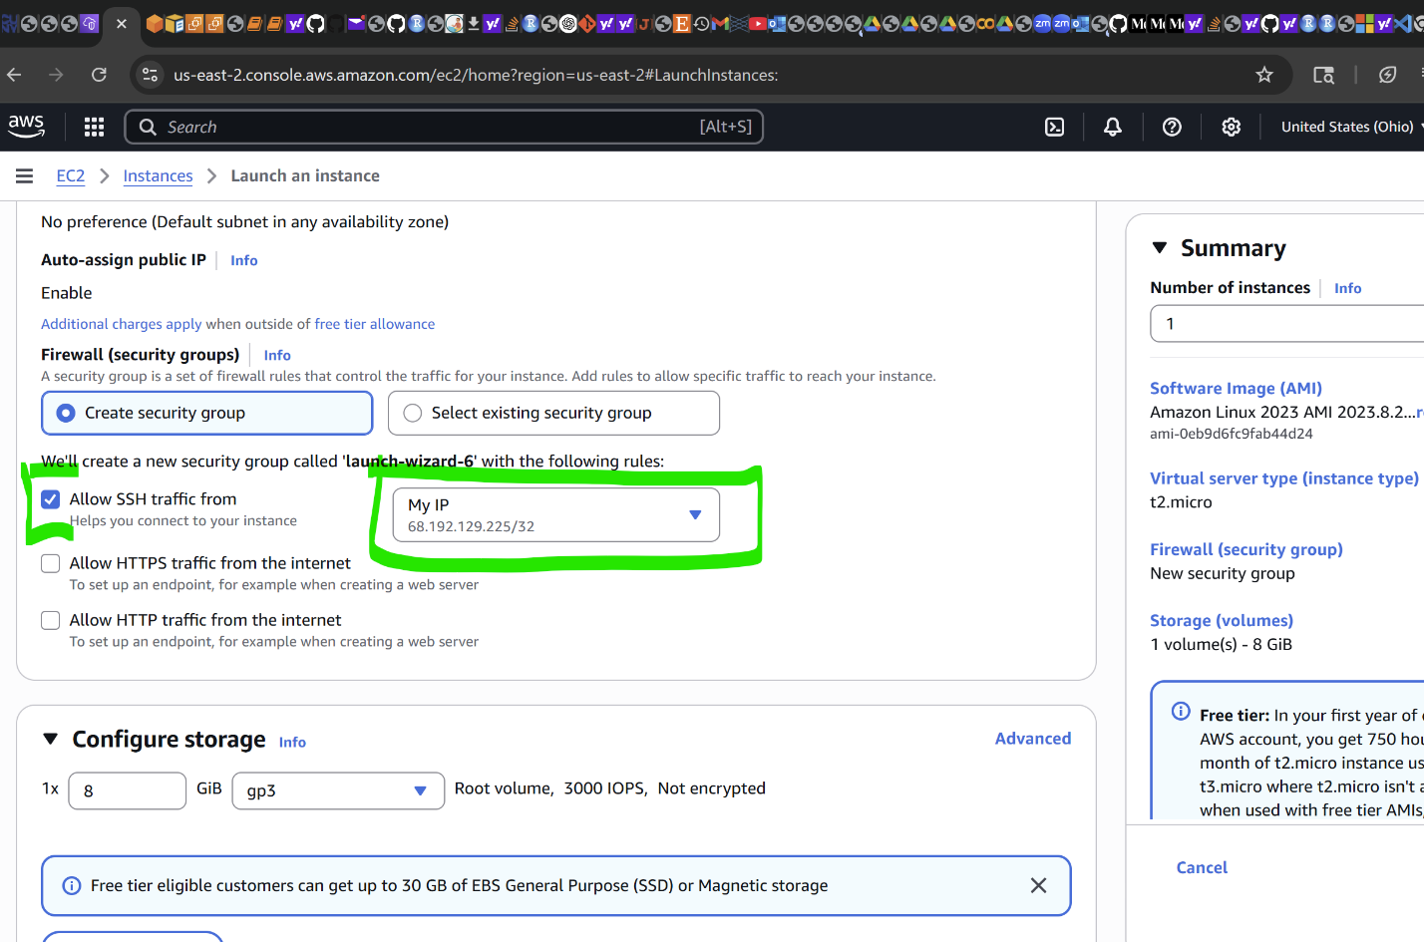

S3

You can upload documents into the S3 bucket.

OTHERS

I USED GIT BASH TO COPY JESTER FILE csv INTO ec2 INSTANCE.

scp -i "C:/Users/pricc/Downloads/AmazonS3things/Mydataproject6kp.pem" "C:/Users/pricc/OneDrive/Desktop/jester-data-1.csv" ec2-user@3.144.73.156:/home/ec2-user/

TO CHECK THAT MY SCRIPT EXISTS

[ec2-user@ip-172-31-36-128 testing]$ ls project4.py

CHANGED FILE PATH IN PY TO FIND FILE IN ec2 INSTANCE

file_path = "/home/ec2-user/jester-data-1.csv"

TO PRINT THE PYTHON FILE i HAVE UPLOADED ON ec2 INSTANCE

[ec2-user@ip-172-31-36-128 testing]$ python3 project4.py to run my script via ssh on visual studio

I UPDATED iP ADDRESS IN CONFIG EACH TIME I RESTARTED THE REMOTE CONNECTION